MIND THE (PAY) GAP!
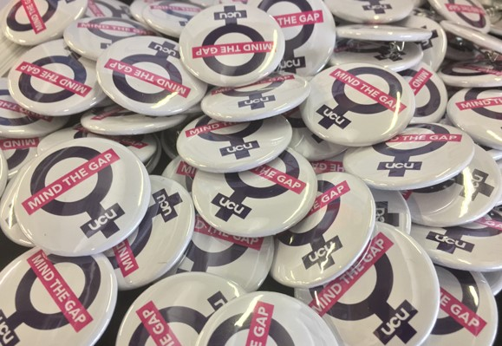

Women, black and minority ethnic staff in universities face a historic legacy of pay inequality. Women lose out at work because of childcare and domestic duties, which can derail career progression. There is still institutional discrimination against BAME staff and women in recruitment and promotion.
The Gender Pay Gap currently stands at 15.1% for HE. It looks low at the OU because all our Associate Lecturers are on one salary grade. For OU Professional Services staff, it is 9.6%. The Ethnicity Pay Gap in the sector is 12-13%.
The HE unions are calling for nationally-agreed action for HE institutions to end this discrimination and close these gaps.

IT’S GONE ON TOO LONG…
UCU and the other 4 unions in HE want:
- A national agreement for an action plan - so each university, including the OU, will take steps to close the Gender and Ethnicity Pay Gaps
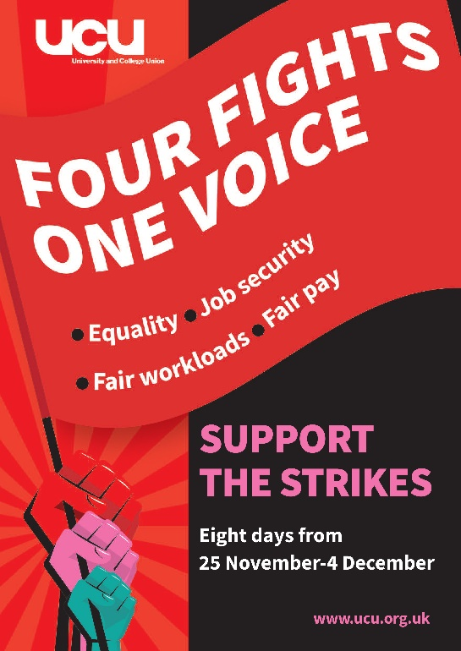
- A commitment by all employers to encourage staff to declare protected characteristics in order to help address discrimination
- A full Equal Pay Audit covering all protected characteristics by an agreed date, with all the aggregated data to be shared with the campus unions.

ACTION ON INEQUALITY = OVERDUE
VALUE ALL EMPLOYEES

